APPENDIX A
Characteristics of Overhead Conductors

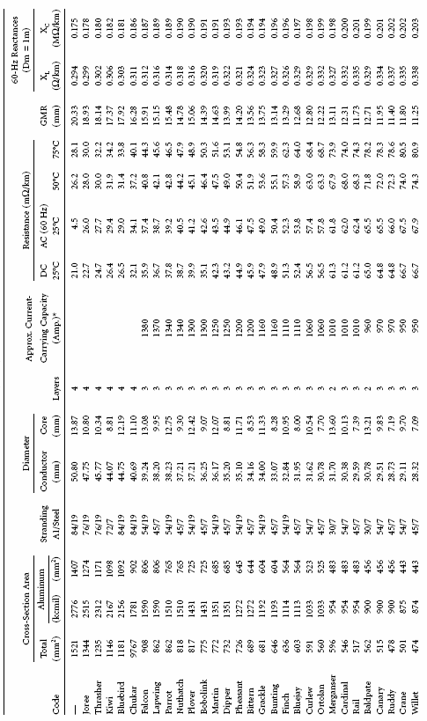
A.1 Characteristics of Aluminum Cable Steel Reinforced Conductors (ACSR)
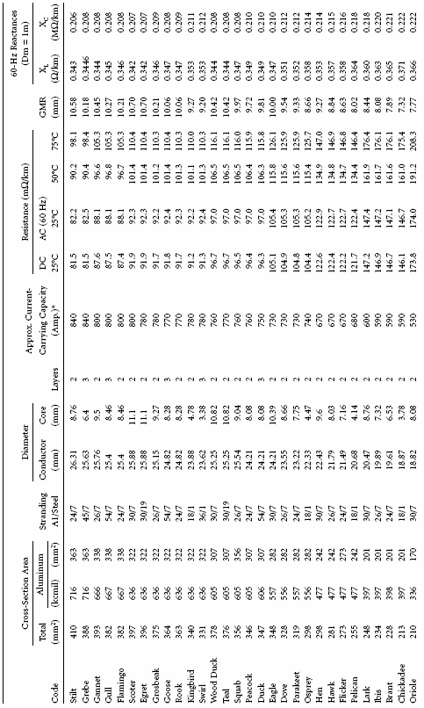
A.2 Characteristics of All-Aluminum Conductors (AAC)
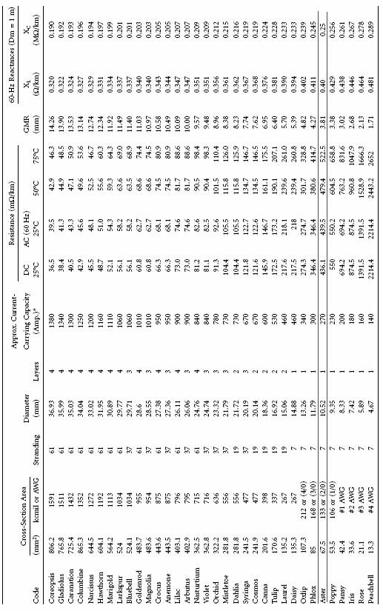

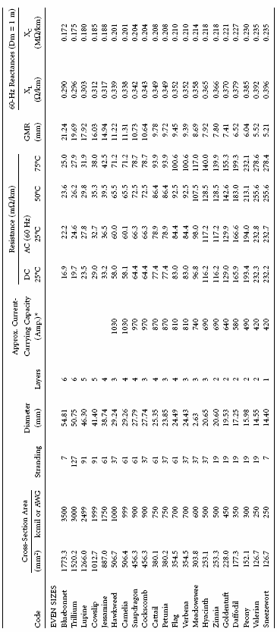

APPENDIX B
Matlab Circuits

B.1 Full Load Circuit
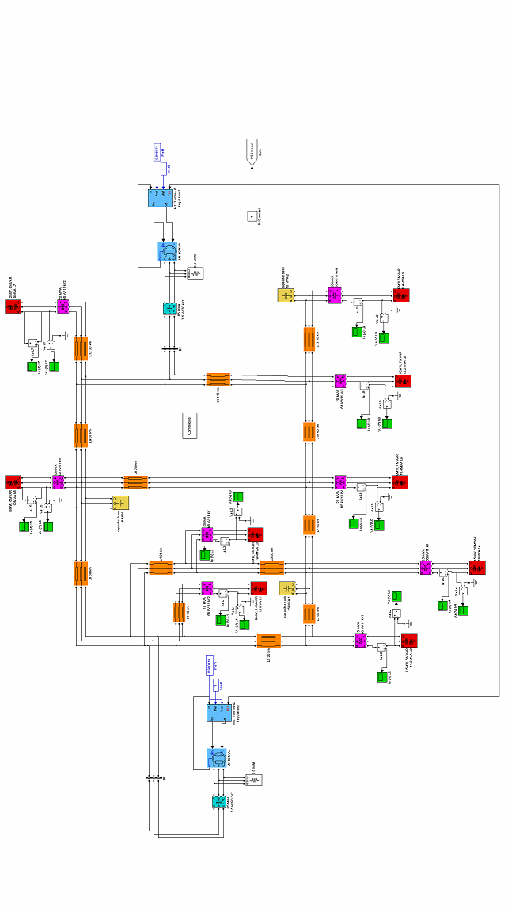

B.2 Overload Circuit
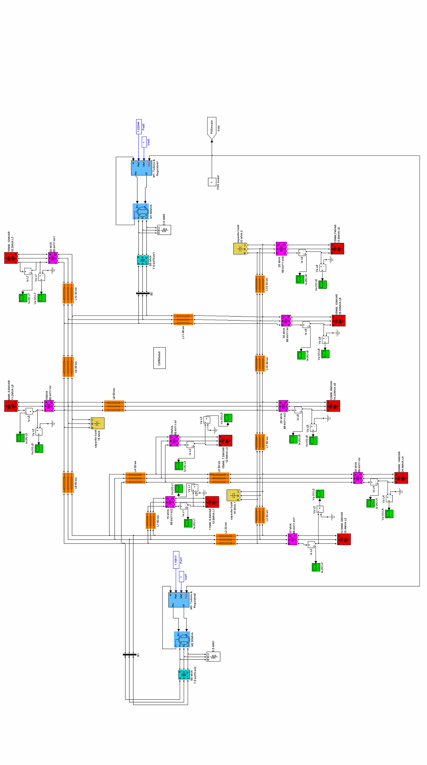

B.3 Bundle Transmission Line (Solution 1)

B.4 Parallel Transmission Line (Solution 2)

B.4 Parallel Generators and Parallel Transmission Line (Solution 3)

B.4 Distribution Generator (Solution 4)

B.4 Parallel Transformer (Solution 5)

APPENDIX C
PSS Circuit &Results
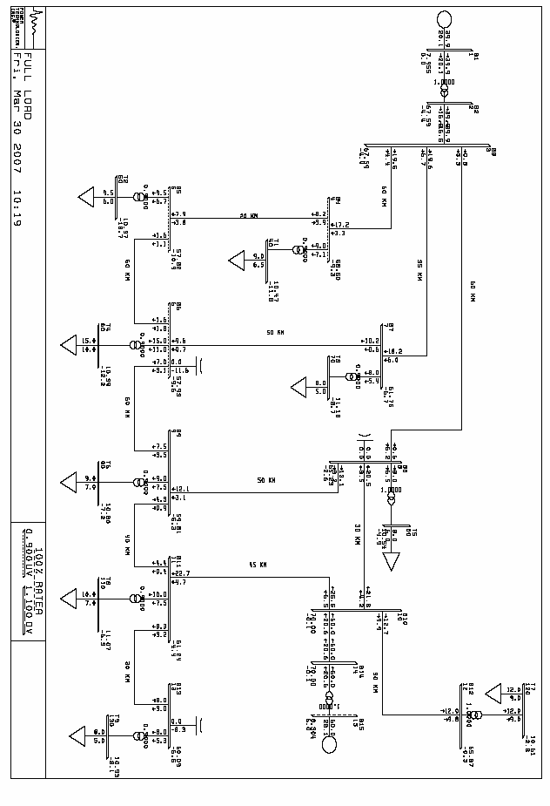

1

PTI INTERACTIVE POWER SYSTEM SIMULATOR--PSS/E Fri, Mar 30 2007 10:20
FULL AND OVER LOAD CIRCUIT RATING
FULL LOAD SET A

BUS 1 B1 7.50 AREA CKT MW MVAR MVA %I 1.0606PU .00 1
GENERATION 1 39.9 20.1R 44.7 63 7.9545KV
TO 2 B2 66.0 1 1 39.9 20.1 44.7 65 1.0000RG

BUS 2 B2 66.0 AREA CKT MW MVAR MVA %I 1.0241PU -4.38 2
1 67.594KV
TO 1 B1 7.50 1 1 -39.9 -16.5 43.2 65 1.0000UN
TO 3 B3 66.0 1 1 39.9 16.5 43.2 42

BUS 3 B3 66.0 AREA CKT MW MVAR MVA %I 1.0241PU -4.38 3
1 67.594KV
TO 2 B2 66.0 1 1 -39.9 -16.5 43.2 42
TO 4 B4 66.0 1 1 19.5 4.4 20.0 63
TO 7 B7 66.0 1 1 19.6 6.7 20.8 66
TO 8 B8 66.0 1 1 .8 5.3 5.4 17

BUS 4 B4 66.0 AREA CKT MW MVAR MVA %I .8864PU -9.26 4
1 58.504KV
TO 3 B3 66.0 1 1 -17.2 -3.3 17.5 64
TO 5 B5 66.0 1 1 8.2 -3.9 9.0 33
TO 40 T1 11.0 1 1 9.0 7.1 11.5 86 .9000LO

BUS 5 B5 66.0 AREA CKT MW MVAR MVA %I .8761PU -10.92 5
1 57.822KV
TO SHUNT .0 -11.5 11.5
TO 4 B4 66.0 1 1 -7.9 3.8 8.8 33
TO 6 B6 66.0 1 1 -1.6 1.1 1.9 7
TO 50 T2 11.0 1 1 9.5 6.7 11.6 88 .9000LO

BUS 6 B6 66.0 AREA CKT MW MVAR MVA %I .8777PU -9.62 6
1 57.930KV
TO SHUNT .0 -11.6 11.6
TO 5 B5 66.0 1 1 1.6 -1.8 2.4 9
TO 7 B7 66.0 1 1 -9.6 -.7 9.6 36
TO 9 B9 66.0 1 1 -7.0 3.1 7.7 28
TO 60 T4 11.0 1 1 15.0 11.0 18.6 85 .9000LO

BUS 7 B7 66.0 AREA CKT MW MVAR MVA %I .9357PU -6.68 7
1 61.754KV
TO 3 B3 66.0 1 1 -18.2 -6.0 19.1 66
TO 6 B6 66.0 1 1 10.2 .6 10.2 35
TO 70 T3 11.0 1 1 8.0 5.4 9.7 69 .9000LO

BUS 8 B8 66.0 AREA CKT MW MVAR MVA %I .9883PU -2.64 8
1 65.226KV
TO 3 B3 66.0 1 1 -.6 -6.2 6.2 20
TO 9 B9 66.0 1 1 13.1 3.2 13.5 44
TO 10 B10 66.0 1 1 -20.5 -3.5 20.8 68
TO 80 T5 11.0 1 1 8.0 6.5 10.3 70 1.0000RG

BUS 9 B9 66.0 AREA CKT MW MVAR MVA %I .9062PU -5.32 9
1 59.809KV
TO 6 B6 66.0 1 1 7.5 -3.5 8.3 30
TO 8 B8 66.0 1 1 -12.1 -3.1 12.5 45
TO 11 B11 66.0 1 1 -4.3 -.9 4.4 16
TO 90 T6 11.0 1 1 9.0 7.5 11.7 65 .9000LO

BUS 10 B10 66.0 AREA CKT MW MVAR MVA %I 1.0606PU -.09 10
1 70.000KV
TO 8 B8 66.0 1 1 21.8 4.2 22.2 68
TO 11 B11 66.0 1 1 25.5 6.5 26.3 80
TO 12 B12 66.0 1 1 12.7 9.9 16.1 49
TO 14 B14 66.0 1 1 -60.0 -20.6 63.4 60

BUS 11 B11 66.0 AREA CKT MW MVAR MVA %I .9279PU -4.40 11
1 61.239KV
TO 9 B9 66.0 1 1 4.4 .4 4.4 16
TO 10 B10 66.0 1 1 -22.7 -4.7 23.2 81
TO 13 B13 66.0 1 1 8.3 -3.2 8.9 31
TO 110 T8 11.0 1 1 10.0 7.5 12.5 67 .9000LO

BUS 12 B12 66.0 AREA CKT MW MVAR MVA %I .9980PU -.32 12
1 65.869KV
TO 10 B10 66.0 1 1 -12.0 -9.8 15.5 50
TO 120 T7 11.0 1 1 12.0 9.8 15.5 78 1.0000RG

BUS 13 B13 66.0 AREA CKT MW MVAR MVA %I .9105PU -6.55 13
1 60.092KV
TO SHUNT .0 -8.3 8.3
TO 11 B11 66.0 1 1 -8.0 3.0 8.5 30
TO 130 T9 11.0 1 1 8.0 5.3 9.6 53 .9000LO

BUS 14 B14 66.0 AREA CKT MW MVAR MVA %I 1.0606PU -.09 14
1 70.000KV
TO 10 B10 66.0 1 1 60.0 20.6 63.4 60
TO 15 B15 7.50 1 1 -60.0 -20.6 63.4 92 1.0000UN

BUS 15 B15 7.50 AREA CKT MW MVAR MVA %I 1.1072PU 6.01 15
GENERATION 1 60.0 28.1R 66.2 94 8.3042KV
TO 14 B14 66.0 1 1 60.0 28.1 66.2 92 1.0000RG

BUS 40 T1 11.0 AREA CKT MW MVAR MVA %I .9521PU -11.83 40
1 10.473KV
TO LOAD-PQ 9.0 6.5 11.1
TO 4 B4 66.0 1 1 -9.0 -6.5 11.1 78 .9000UN

BUS 50 T2 11.0 AREA CKT MW MVAR MVA %I .9426PU -13.69 50
1 10.369KV
TO LOAD-PQ 9.5 6.0 11.2
TO 5 B5 66.0 1 1 -9.5 -6.0 11.2 79 .9000UN

BUS 60 T4 11.0 AREA CKT MW MVAR MVA %I .9446PU -12.23 60
1 10.390KV
TO LOAD-PQ 15.0 10.0 18.0
TO 6 B6 66.0 1 1 -15.0 -10.0 18.0 76 .9000UN

BUS 70 T3 11.0 AREA CKT MW MVAR MVA %I 1.0160PU -8.71 70
1 11.176KV
TO LOAD-PQ 8.0 5.0 9.4
TO 7 B7 66.0 1 1 -8.0 -5.0 9.4 62 .9000UN

BUS 80 T5 11.0 AREA CKT MW MVAR MVA %I .9583PU -4.90 80
1 10.541KV
TO LOAD-PQ 8.0 6.0 10.0
TO 8 B8 66.0 1 1 -8.0 -6.0 10.0 70 1.0000UN

BUS 90 T6 11.0 AREA CKT MW MVAR MVA %I .9814PU -7.15 90
1 10.796KV
TO LOAD-PQ 9.0 7.0 11.4
TO 9 B9 66.0 1 1 -9.0 -7.0 11.4 58 .9000UN

BUS 110 T8 11.0 AREA CKT MW MVAR MVA %I 1.0060PU -6.33 110
1 11.066KV
TO LOAD-PQ 10.0 7.0 12.2
TO 11 B11 66.0 1 1 -10.0 -7.0 12.2 61 .9000UN

BUS 120 T7 11.0 AREA CKT MW MVAR MVA %I .9644PU -2.82 120
1 10.608KV
TO LOAD-PQ 12.0 9.0 15.0
TO 12 B12 66.0 1 1 -12.0 -9.0 15.0 78 1.0000UN

BUS 130 T9 11.0 AREA CKT MW MVAR MVA %I .9936PU -8.14 130
1 10.930KV
TO LOAD-PQ 8.0 5.0 9.4
TO 13 B13 66.0 1 1 -8.0 -5.0 9.4 47 .9000UN

--------------------------------------------------------------------------------

1 PTI INTERACTIVE POWER SYSTEM SIMULATOR--PSS/E Fri, Mar 30 2007 10:21
FULL AND OVER LOAD CIRCUIT
FULL LOAD

TRANSMISSION LINE LOADINGS ABOVE 100.0 % OF RATING SET A:

X-------FROM BUS-------X X--------TO BUS--------X CURRENT(MVA)
BUS NAME BSKV AREA BUS NAME BSKV AREA CKT LOADING RATING PERCENT

* NONE *

--------------------------------------------------------------------------------

1 PTI INTERACTIVE POWER SYSTEM SIMULATOR--PSS/E Fri, Mar 30 2007 10:21
FULL AND OVER LOAD CIRCUIT
FULL LOAD

TRANSFORMER LOADINGS ABOVE 100.0 % OF RATING SET A:

X-------FROM BUS-------X X--------TO BUS--------X MVA MVA
BUS NAME BSKV AREA BUS NAME BSKV AREA CKT LOADING RATING PERCENT
14 B14 66.0 1 15* B15 7.50 1 1 66.2 65.0 101.9

--------------------------------------------------------------------------------

1 PTI INTERACTIVE POWER SYSTEM SIMULATOR--PSS/E Fri, Mar 30 2007 10:21
FULL AND OVER LOAD CIRCUIT
FULL LOAD

BUSES WITH VOLTAGE GREATER THAN 1.0500:

X------ BUS -----X AREA V(PU) V(KV) X------ BUS -----X AREA V(PU) V(KV)
1 B1 7.50 1 1.0606 7.955 10 B10 66.0 1 1.0606 70.000
14 B14 66.0 1 1.0606 70.000 15 B15 7.50 1 1.1072 8.304

BUSES WITH VOLTAGE LESS THAN .9500:

X------ BUS -----X AREA V(PU) V(KV) X------ BUS -----X AREA V(PU) V(KV)
4 B4 66.0 1 .8864 58.504 5 B5 66.0 1 .8761 57.822
6 B6 66.0 1 .8777 57.930 7 B7 66.0 1 .9357 61.754
9 B9 66.0 1 .9062 59.809 11 B11 66.0 1 .9279 61.239
13 B13 66.0 1 .9105 60.092 50 T2 11.0 1 .9426 10.369
60 T4 11.0 1 .9446 10.390

--------------------------------------------------------------------------------

1 PTI INTERACTIVE POWER SYSTEM SIMULATOR--PSS/E Fri, Mar 30 2007 10:21
FULL AND OVER LOAD CIRCUIT
FULL LOAD

*********************** SUMMARY FOR COMPLETE SYSTEM ***********************

SYSTEM SWING BUS SUMMARY
BUS X---NAME---X X--- AREA ---X X--- ZONE ---X MW MVAR MVABASE
1 B1 7.50 1 [ ] 1 [ ] 39.9 20.1 70.6

24 BUSES 2 PLANTS 2 MACHINES 9 LOADS
26 BRANCHES 11 TRANSFORMERS 0 DC LINES

X------ ACTUAL ------X X----- NOMINAL ------X
MW MVAR MW MVAR
FROM GENERATION 99.9 48.2 99.9 48.2
TO CONSTANT POWER LOAD 88.5 61.5 88.5 61.5
TO CONSTANT CURRENT .0 .0 .0 .0
TO CONSTANT ADMITTANCE .0 .0 .0 .0
TO BUS SHUNT .0 -31.4 .0 -40.0
TO LINE SHUNT .0 .0 .0 .0
FROM LINE CHARGING .0 8.9 .0 9.9

VOLTAGE X----- LOSSES -----X X-- LINE SHUNTS --X CHARGING
LEVEL BRANCHES MW MVAR MW MVAR MVAR
66.0 17 11.42 21.60 .0 .0 8.9
11.0 9 .00 5.38 .0 .0 .0

